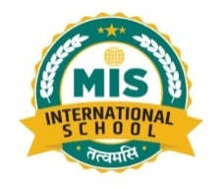

**MIS INTERNATIONAL SCHOOL**

**SOP for Examination 2025- 26**

1. Portion of Exam should be given in prior, one month before the exams.
2. Completion of portion for ,

Periodic Tests: One week before Periodic Test.

Term Exams: Two weeks before the exam starts.

1. Revision should be done prior to the exam.
2. Papers along with the answer keys are to be submitted before 15 days of every exam.
3. Mark list to be collected before one week of exam.
4. Distribution of marks and weightage across the section.

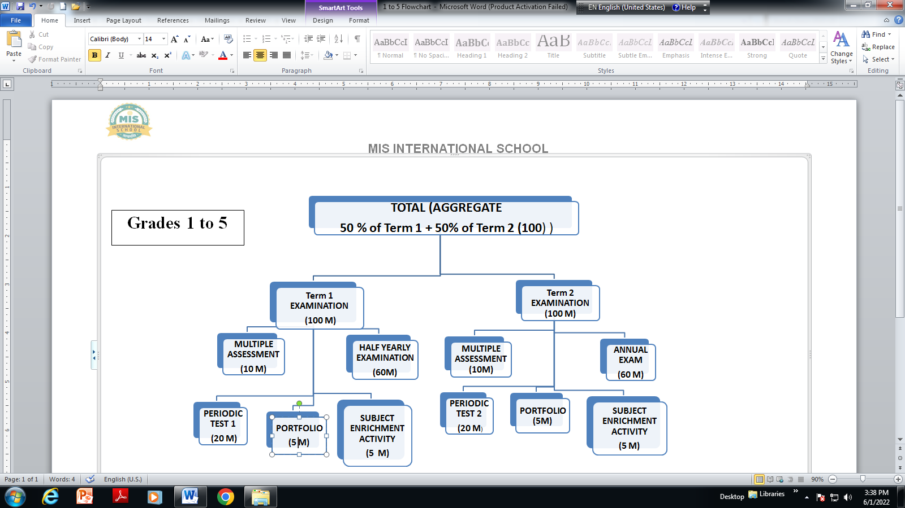

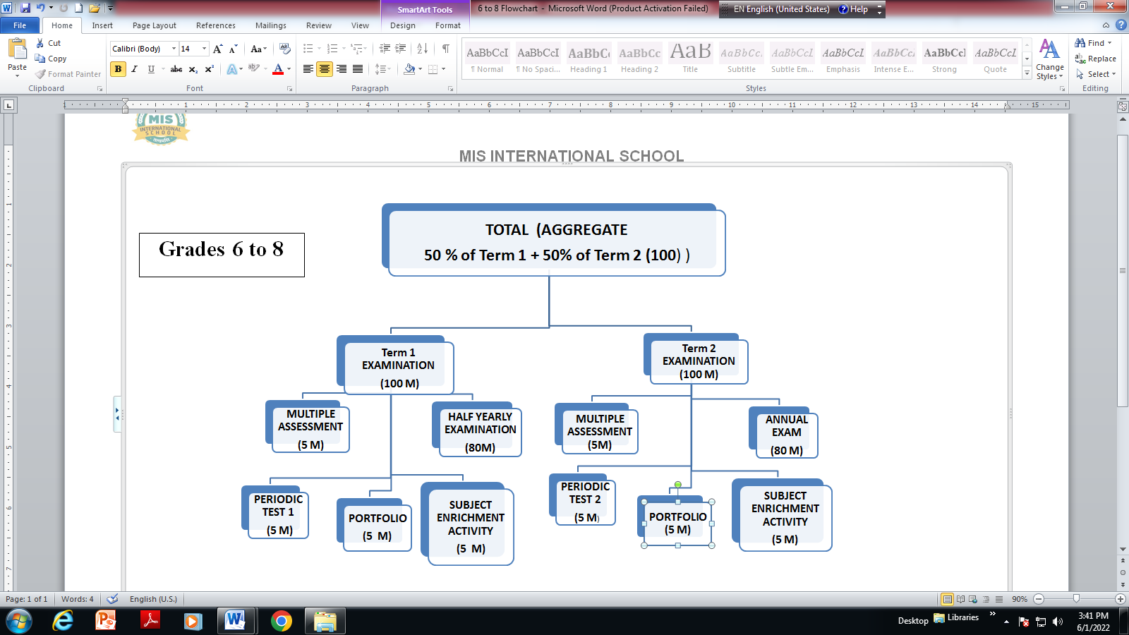

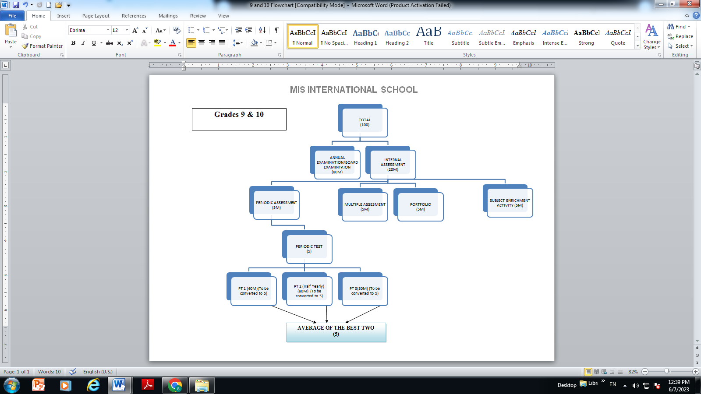

1. Papers should be thoroughly checked.

* Competency Based Questions would be a minimum 40%

These can be in the form of Multiple Choice Questions, Case-based Integrated Questions, Source-based Integrated Questions or any other types.

* Objective Type Questions will be 20%
* Remaining 40% short.
* Avoid giving the questions out of the course. Include Application-based questions.

1. Marks distribution should be justifying number of sub-questions given under the main question. No error in maximum marks, no spelling mistakes, and grammatical errors in question papers.
2. Checking to be done with red pen. Page wise subtotal to be written below answer script. Encircle the marks by the examiner to be signed against total of the marks.
3. General remarks should be typed by class teachers and checked by the Principal ma’am within a week before the Term exam.
4. Cross-checking has to be done by cross-checker after the correction of a bundle of exam papers. Cross checker should sign on each paper after cross-checking.
5. Follow the timeline and submit the things.
6. Marks entry is to be done in result sheet (excel sheet) as well as on the Edunext portal by the class teacher and subject teachers.
7. Co-Scholastics subjects like Art and Craft, P.E, Value Education, Music & Dance entry should be done on the basis of 5 points grading scale A, B, C, D, E.
8. Discipline grading should be done by the class teachers on the basis of 3 points grading scale A, B, C.
9. Attendance should be calculated on term basis.
10. A subject teacher is not allowed to go to the classes where his/her exam is being conducted. In case of any doubt or query during examination invigilator should inform to the exam department.
11. Soft copy of question papers, blueprints and answer keys should be mailed to the

respective HOD’s in a specified format within stipulated time.

1. Competency Focused Questions in the form of MCQs/Case Based Questions, Source-based integrated Questions or any other type =50%.

Gr 11 & 12

1. Select response type questions(MCQ)=20%
2. Constructed response questions (short Answer/Long Answer Type Questions, as per existing pattern) = 30%.

